To become an Active member of the Dynamic Team of the Organization, accept challenges, contribute to Organizational goals and further improve my professional skills and to become master in my field.

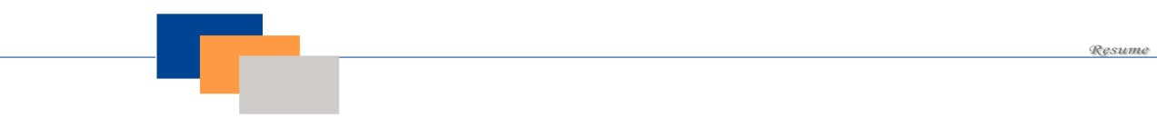

**Syed Azbar Hasnain Ali**

CONTACT

:

(

+92

)

319-0695414)

_

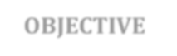

**OBJECTIVE**



**PERSONAL INFORMATIO**

**N**



 Father’s Name: syed khalid Mehmood

 Date of Birth: 12-10-2002

 CNIC #: 42201-7269580-0

 Domicile: Karachi

 Religion: Islam

 Nationality: Pakistani

 Marital Status: Single



**ACADEMIC**

**QUALIFICATION**



***Certificate* Session Marks (O/T) Board/University**

|  |  |  |  |
| --- | --- | --- | --- |
| Matriculation (science) | 2020 | 500/800 | SGHSchool, karachi |
| *intermediate (commerce)* | 2022 | 700/1000 | Govt Quaid Azam College krongi,karachi |



**PROFESSIONAL**

**QUALIFICATION**



 03-year diploma in process from APTECH, karachi.



**EXPERIENCE**



Fresh Front-End Developer – Developed 9 pages of static Metric

Conversion type website and worked on many more projects individually



**WORKING POTENTIAL**

▪

Enthusiasm of working hard in any field and in any type of working environment.

▪

Able to learn

quickly and to take responsibility of work.

▪

Understand the nature of work and have the ability to achieve goals as specified.

▪

Well

-

mannered and can prove to be a good team member.



**LANGUAGE**

**SKILLS**



|  |  |  |  |
| --- | --- | --- | --- |
| **Language** | **Read** | **Write** | **Speak** |
| English | Good | Average | Average |
| Urdu | Excellent | Excellent | Excellent |



**OTHER ACTIVITIES**



* Reading books .
* General discussion.
* Traveling
* Searching on Internet

**DECLARATION**



I declared that the information furnished is true and correct to the best of my knowledge and belief. Any references can be furnished on demand.

https://github.com/Hasnain11222/new-hub



**Social Links**

